MATRAVILLE SPORTS HIGH SCHOOL

SCHOOL POLICY FOR MANAGEMENT OF
BULLYING, HARASSMENT AND CYBERBULLYING

“The community of Matraville Sports High School
are committed to ensuring a safe and caring
environment in which the rights of others and
individual differences are respected”.

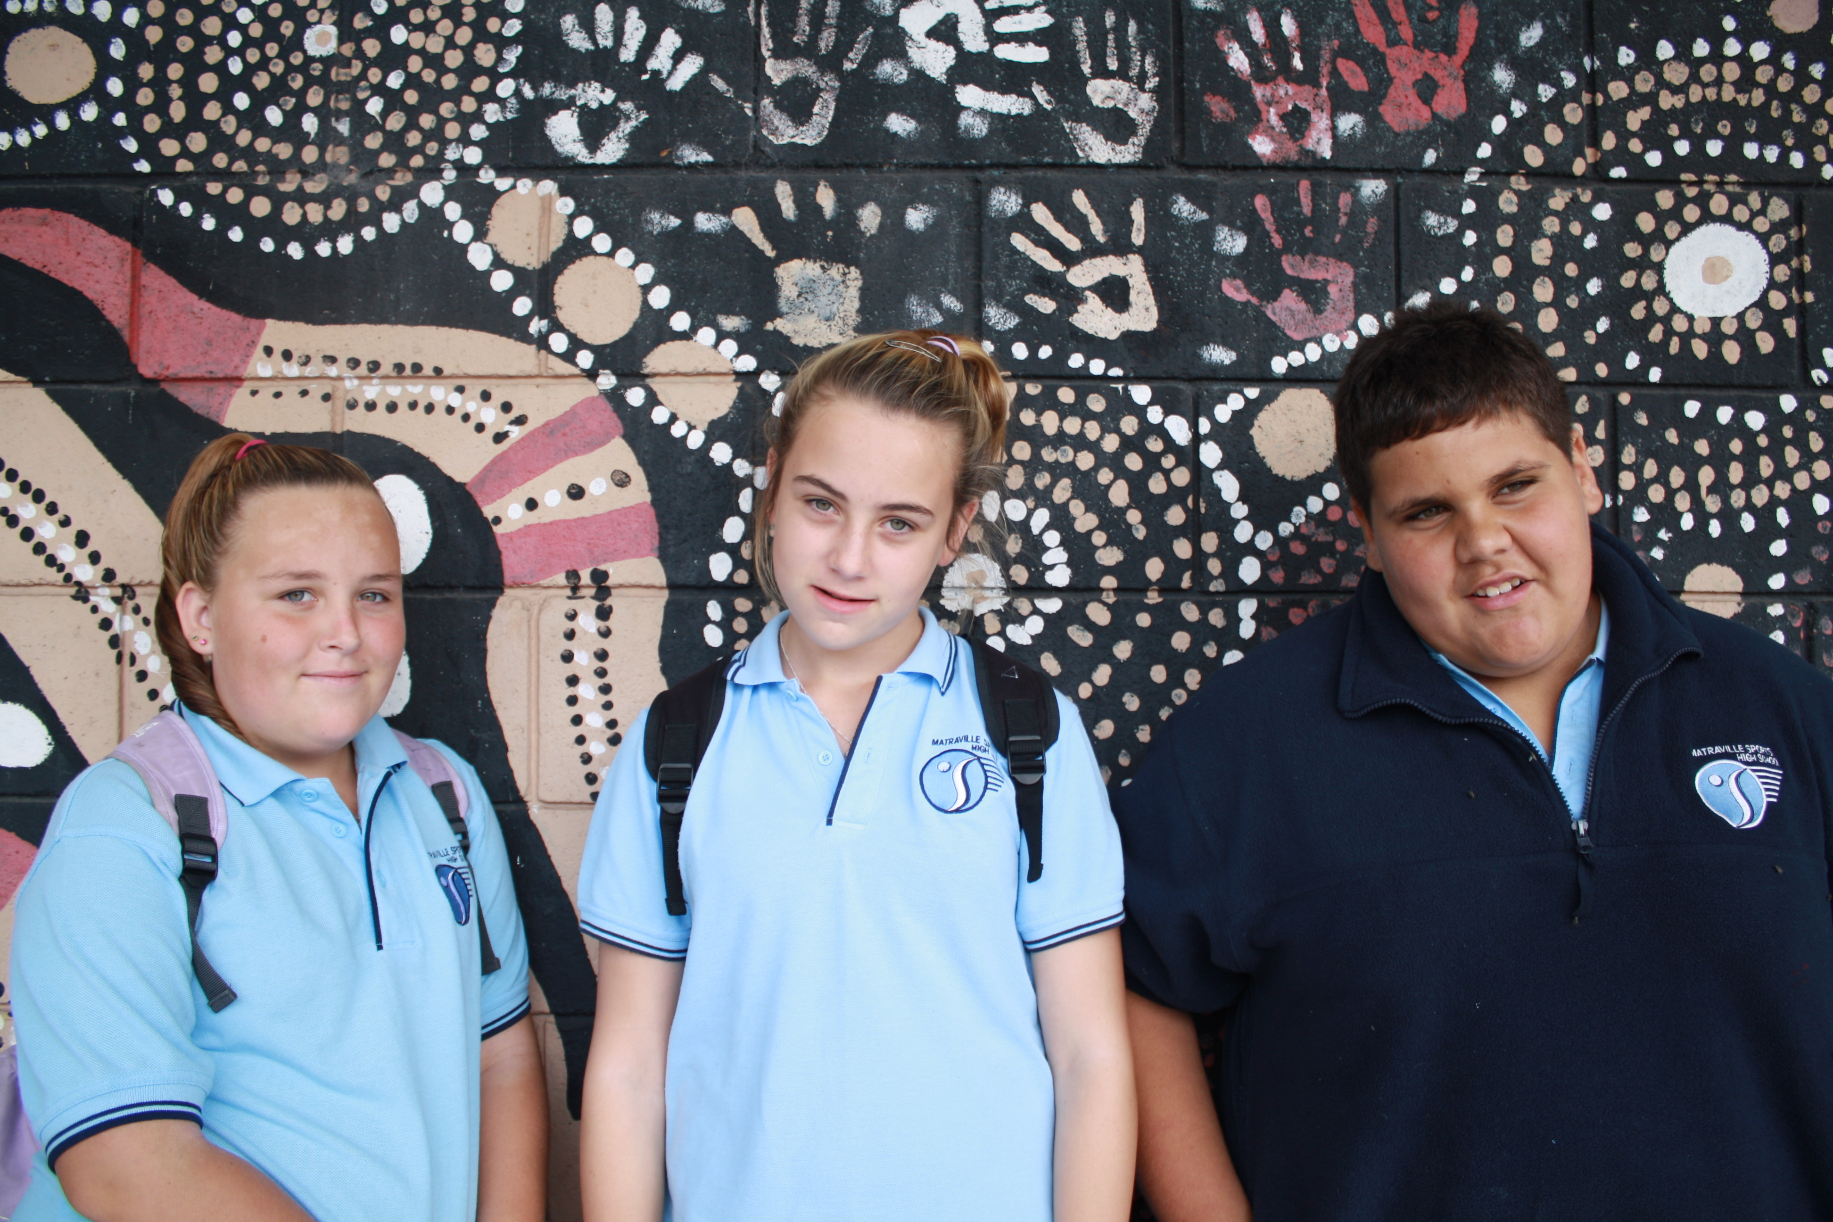

“At Matraville Sports High School,
Bullying and harassment will not be
tolerated in any form. Everyone has the right to learn in a safe and
non threatening environment, free from any form of bullying.
”.

Revised March 2012

What is Bullying?

Matraville Sports High School defines bullying as any action or behaviour that is verbal, non-verbal, written, cyber, physical or psychological by groups or individuals, intentionally or unintentionally that causes a person to feel unsafe, unhappy, powerless or fearful.

Harassment is an aspect of bullying that involves stereotyping and prejudice. No-one has the right to harass or discriminate against another person on the basis of race, gender, culture, sexual preference, religion, disability or physical appearance.

Cyber bullying refers to bullying through information and communication technologies. Cyber bullying occurs when the internet, email or mobile phones are used to deliberately and repeatedly engage in hostile behaviour to harm someone

Examples of bullying and harassment are:
• Verbal abuse (name calling, teasing, swearing)
• Intimidation and threats (standing over another person)
• Physical abuse (punching, pushing, spitting, fighting)
• Rumours, malicious gossip, offensive comments (verbal or written)
• Removing, hiding, damaging or destroying the property of others
• Making degrading comments about another’s cultural, religious or social background
• Making suggestive comments or other forms of sex-based harassment
• Hurtfully and deliberately excluding peers from a group
• Sending nuisance phone calls or unwanted text messages and/or images by mobile phone or via the internet e.g. email, MSN, Facebook

Not all fighting or conflict is bullying or harassment. Bullying and harassment are patterns of behaviour that keep on happening. If you are being bullied you may feel scared, stressed, depressed, angry or unsafe. It is often difficult to speak up about being bullied but you have a right to feel safe and respected and no-one can help if they don’t know what is going on.

Bullying and harassment are not acceptable at Matraville Sports High School.

What strategies do we use to prevent bullying at Matraville Sports High School.

Students: have a responsibility to
Behave appropriately, respecting individual differences and diversity
Behave as responsible citizens
Follow the MSHS Anti Bullying policy
Display responsible bystander behaviour
Report all observed and known incidents of bullying
Staff: have a responsibility to:
• Be role models in words and actions at all times
• Be observant of signs of distress or suspected incidents of bullying and harassment
• Be vigilant in the classroom and playground
• Take appropriate action and/ or refer situations to Year Adviser or HT Engagement
School:
• All members of the school community promote and create a safe environment
• Workshops and performances through Student welfare Programs
• Mediation training
• Mentor program
• Police Liaison Officer presentations and interventions
Parents/Guardians: have a responsibility to:
• Be aware of the school’s anti Bullying policy and assist your child in understanding bullying behaviour.
• If you suspect your child is being bullied or involved in or aware of a bullying situation, discuss ways to deal with the bullying
• Advise your child to tell a staff member about the bullying behaviour
• Inform the Year Adviser of any cases of bullying even if your child is not directly affected
• Participate in anti-bullying awareness programs and work together against bullying at Matraville Sports High School.

How to deal with bullying and harassment?
If you are harassed or bullied you can take a number of steps:
- if it only happens once and you can cope with it, you could ignore the behaviour
- if it continues, you could say to the bully “Stop it. You are bullying me and I don’t like it”
- try and stay in a group and not be by yourself
- always talk it over with people you trust – friends and/or family – who can help plan how to deal with the bullying
- you can report it to your teacher, Year Adviser or HT Engagement who will take action to stop the bullying (see below).
If you know someone who is being bullied or harassed:
- Report the bullying to a staff member
- Talk to them about it and ask how you can support them
- Try to make sure they are not alone at times when they could be bullied or harassed.
- Practice positive bystander behaviour

What actions will occur if bullying or harassment continues?

- If the bullying behaviour persists see your Year Adviser who can refer the situation to the Head Teacher Engagement and/or Deputy Principal who will then take action to stop the bullying or harassment.
- If the situation continues or escalates, the Deputy Principal will issue a warning to the bully and their parents will be contacted.
- The bully will be issued a warning letter which is to be taken home, signed by a parent/guardian, and returned to the Deputy Principal.
- If the bullying still continues this may lead to suspension and follow up parent meeting.
Other intervention may include:
- Individual or group mediation by the Year Adviser, HT Welfare or School Counsellor parent contact
- Year Adviser, Head Teacher Engagement or Deputy Principal discussing strategies with students and parents
- Student taking part in the school’s mediation program and restorative Practices Program.
- Accessing confidential counselling from the School Counsellor.
- Use of restorative Practices
- Bystander training in 2012 for SRC and Years 7/8 and 9.

What is Cyber-bullying

Cyberbullying is a form of bullying using text or images posted on personal websites or sent by mobile phone or email. Cyberstalking occurs when a person is stalked or harassed by another person using email or other electronic messaging system. The stalking may be frequent, intrusive and involve threats or sexual innuendo.

At Matraville Sports High School cyber-bullying is not acceptable.

What should you do if you are subject to cyber-bullying or stalking?

Immediately inform your parent/caregiver.
If you know the person, you should contact him/her and ask him/her to stop.
Block the offender from your page.
Print/save a copy of offending messages if possible, to allow for effective follow up.
If the person is a student at Matraville Sports High School, report the incident to your Year Adviser or Head Teacher Engagement
If the person is not a student at Matraville Sports High school, report the incident to the police.

What are the consequences for cyber-bullying or stalking?

It is a criminal offence with possible legal repercussions to use emails, telephones or text messaging:

- to threaten to kill or harm a person where the intention is to make the other person fearful that the threat will be carried out
- if the content of the messages or phone calls can be regarded as threatening, harassing or offensive
- to intimidate a person for the purpose of causing someone fear of physical or psychological harm.

You, or your parent/caregiver need to contact the police who will take whatever action is necessary.
A Police Youth Liaison Officer is available to assist you at Maroubra Police Station.

How will cases of cyber-bullying or stalking be dealt with at Matraville Sports High School?

Depending on the individual case and the nature of the material, criminal or civil actions may be taken by the person(s) being bullied:
- see your Year Adviser who can refer the situation to the Head Teacher Engagement and/or Deputy Principal who will take action to stop the bullying behaviour
- if the situation continues or escalates, Deputy Principal will contact parents and the perpetrator(s) will be issued a warning letter to be taken home, signed by a parent/caregiver, and returned to the Deputy Principal.
- in the event of continued threat or inappropriate messaging, the student(s)responsible will be suspended
- parents of the suspended student(s) will be advised of legal rights and ramifications
- support of local Police Liaison Officer will be accessed
- opportunities for students to recognise and be able to respond to incidents will be provided through workshops and guest speakers as part of the school’s student welfare programs throughout the year.
.

Safe sexting: No such thing

Do not post images of yourself or your friends and do not distribute any sent to you.
Sexting can lead to humiliation, cyber-bullying or even sexual assault.
Images sent by mobile phone or on the internet can easily fall into the wrong hands and once in cyberspace it is impossible to remove them or control who sees them.

Useful online resources

http://au.reachout.com (and then search for ‘bullying’ or ‘cyberbullying’)

http://www.bullyingnoway.com.au

http://www.cyh.com

http://www.schools.nsw.edu.au/news/ezine

Think before you act!
RESPONSE and EARLY INTERVENTION

In all cases of bullying the person doing the bullying will be counselled and appropriate consequences discussed. The person being bullied will be supported and counselled.

REPORTING PROCEDURES

STEP 1
Immediately report the bullying to the teacher. Tell the closest teacher to the bullying incident. You may also tell any teacher you feel comfortable with.

STEP 2
That teacher will investigate and try to solve the problem through the implementation of the new school rules(Matra Matters) and expectations, restorative justice practices/choice theory. If necessary the Head Teacher for that subject will be notified (within 2 days).

STEP3
If the problem is still unresolved, it will then be referred to the Deputy Principal who may involve the Year Advisor where appropriate (within 5 days).

STEP 4
If there is any aggressive behaviour involved, the teacher will report the incident immediately to the Head Teacher who will then follow the school’s discipline policy.

STEP 5
Any incident involving assaults, threats, intimidation or harassment will be taken directly to the Deputy Principal who may then involve the Principal, SED and/or Police where necessary

STEP 6
Where there are any concerns for a student’s wellbeing, this will be reported directly to the Child Wellbeing Unit by the Deputy Principal.

